Microeconomics Group Assignment 3
Fogel Study Group 1
Nowa Imasekha
Chen Fengqiao
Shu T ang
Shori Ando
Oran Aviv
Derrick Teo

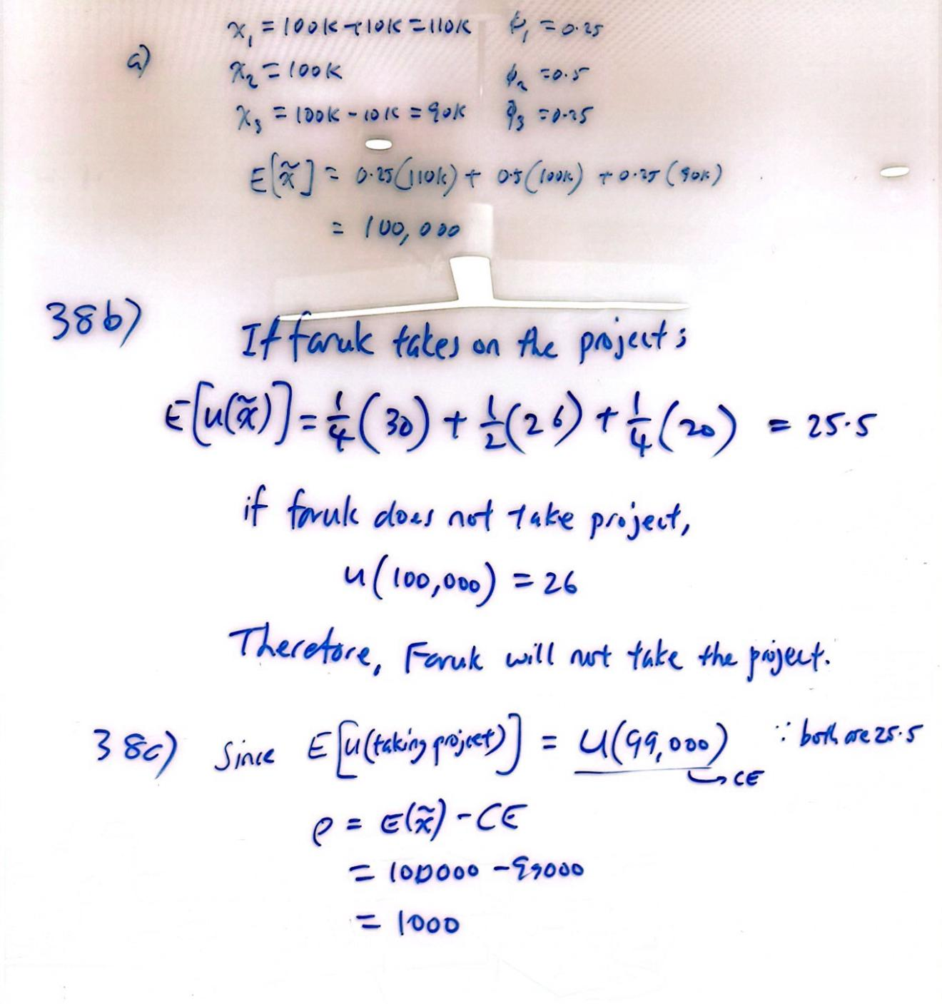
Q38
Q39

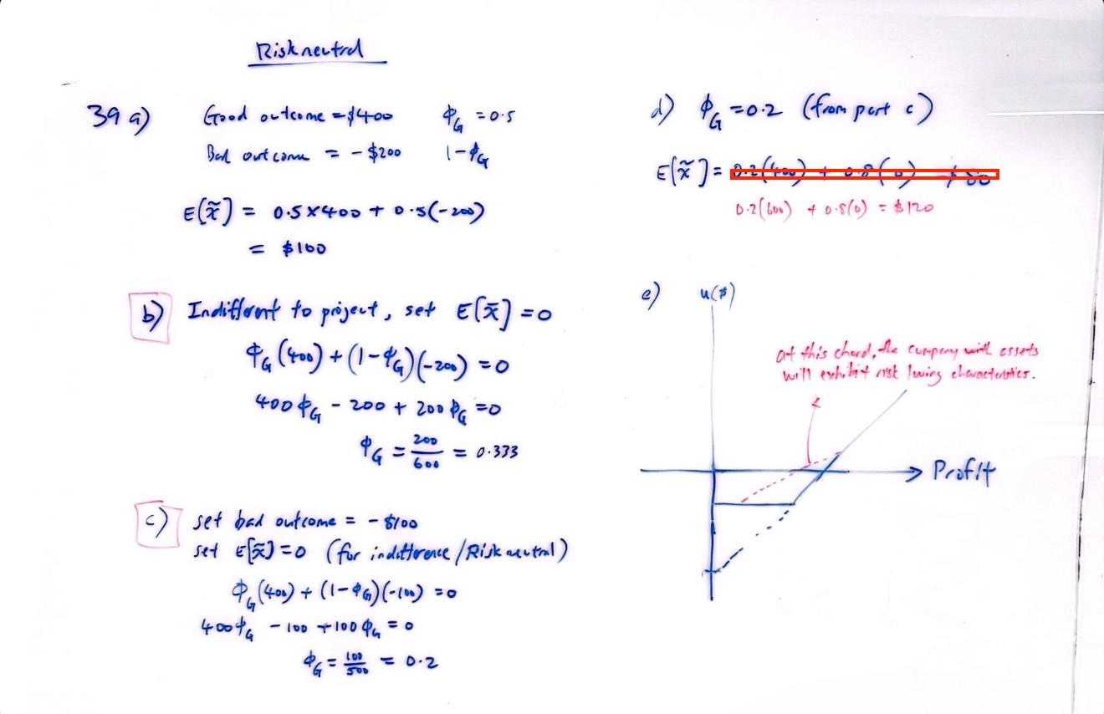

Q43

